**PLATFORM AS A SERVICE**

**INTRODUCTION**

Platform as a service (PaaS) or application platform as a service (aPaaS) or platform-based service is a category of cloud computing services That allows customers to provision, instantiate, run, and manage a modular bundle comprising a [computing platform](https://en.wikipedia.org/wiki/Computing_platform) and one or more applications, without the complexity of building and maintaining the infrastructure typically associated with developing and launching the application(s); and to allow developers to create, develop, and package such software bundles.

TYPES OF PAAS

**1.**PaaS tied to a SaaS product

These PaaS offerings are tightly connected to commonly-used SaaS platforms like Salesforce, Workday, or Intuit. The purpose of this kind of PaaS is to create a developer ecosystem around a SaaS application. It does this by providing a platform allowing ISVs to create new capabilities that run on the core SaaS platform. Examples of added capabilities might be custom business processes, platform extensibility, data model customization, or a broad range of new functionality. Many of these platforms have low-code/ no-code capabilities, meaning they can be used by less technical resources.

In this way, new capabilities can be rapidly created to meet market demand and then sold into the customer base directly or via an application marketplace.

Examples of this kind of PaaS are:

* [Workday Cloud Platform](https://www.trustradius.com/products/workday-cloud-platform/reviews)
* [Salesforce App Cloud/Lightning](https://www.trustradius.com/products/salesforce-lightning-platform/reviews)
* [Google App Engine](https://www.trustradius.com/products/google-app-engine/reviews)
* [Intuit Developer Network](https://www.trustradius.com/products/intuit-developer-network/reviews)

Most of these PaaS tools are provided to customers or ISVs free of cost by the vendor, although fees may be charged up to a certain level of resources consumed, such as storage, bandwidth, or hours used.

### 2.**PaaS tied to an Operating Environment**

The most common example of this is an Infrastructure-as-a-Service (IaaS) vendor including [PaaS capabilities](https://www.trustradius.com/buyer-blog/cloud-computing-saas-iaas-and-paas) as part of the IaaS offering and encroaching further up the stack. These offerings may not have the same depth of functionality as standalone PaaS platforms, but they can work well if the customer is committed to running only on one specific IaaS. Some buyers may worry about vendor lock-in.

Examples of this type of PaaS are:

* [AWS Elastic Beanstalk](https://www.trustradius.com/products/aws-elastic-beanstalk/reviews)
* [AT&T PaaS](https://www.trustradius.com/products/at-t-iot/reviews)
* [Microsoft Azure](https://www.trustradius.com/products/microsoft-azure/reviews)

### 3.**Open-cloud PaaS**

This kind of PaaS is not tied to a SaaS product or operating environment but allows organizations to use a completely separate platform. This provides flexibility, but can also add cost. These platforms are generally suitable for hybrid cloud environments.

Examples of Open-Cloud PaaS include:

* [Engine Yard](https://www.trustradius.com/products/engine-yard/reviews)
* [Jelastic](https://www.trustradius.com/products/jelastic/reviews)
* [Apprenda](https://www.trustradius.com/products/apprenda/reviews)
* [Cloud Foundry](https://www.trustradius.com/products/cloudfoundry/reviews)

### 

**Cloud Services**

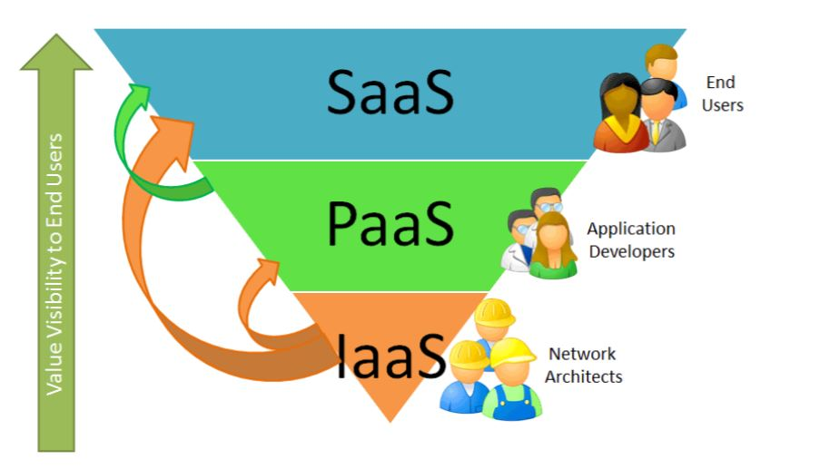 **PaaS Characteristics**

• Multi-tenant architecture

• Built-in scalability of deployed software

• Integrated with web services and databases

• Users are provided with tools to simplify creating and deploying applications

• Simplifies prototyping and deploying startup solutions